**Parameter action scenario**

Using parameter action done this scenario

Use parameter actions to let your audience change a parameter value through direct interaction with a viz, such as clicking or selecting a mark. You can use parameter actions with reference lines, calculations, filters and SQL queries, and to customise how you display data in your visualisations.

Parameter actions open up new possibilities for creating summary values and statistics without using calculations. You can configure parameter actions to let users select multiple marks that are automatically aggregated into a single parameter value. For example, a parameter action could show the AVG(Sales) or COUNTD(Orders) for currently selected marks.

Create two sheet1 and sheet 2

In sheet1 we built a report as measures names in the sheet

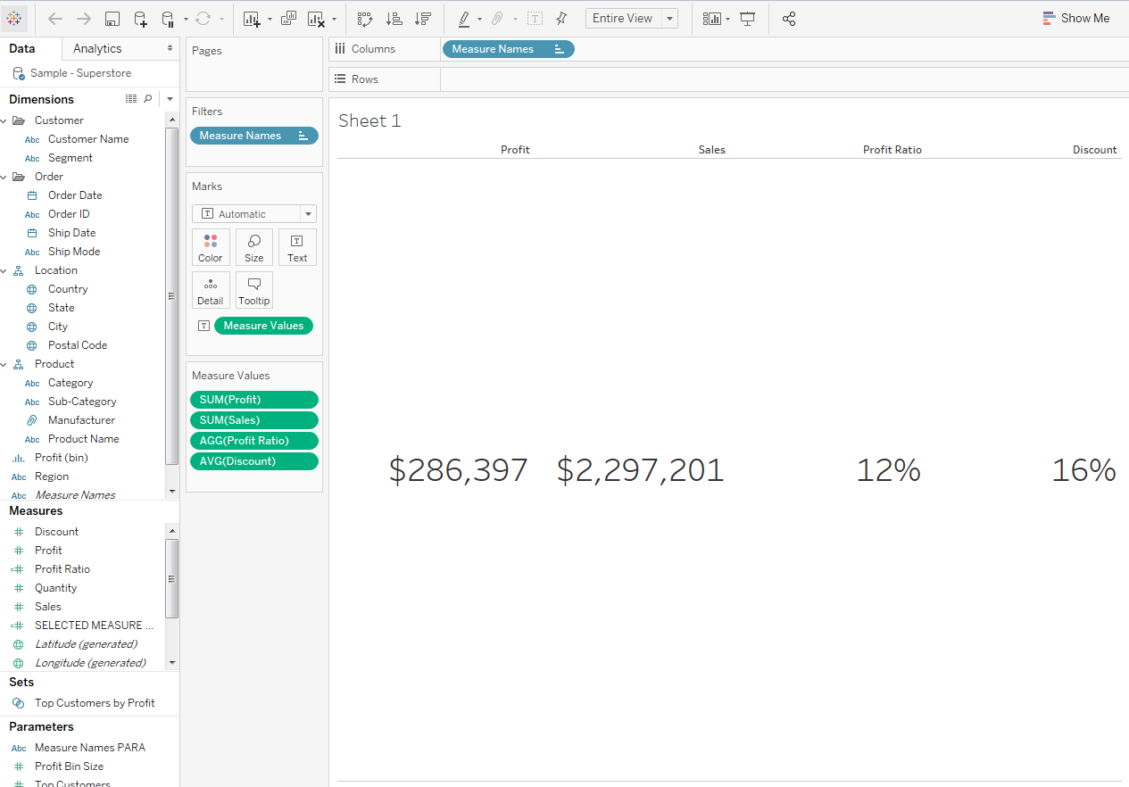

Like that above we create the another sheet as orderdate and its metrics

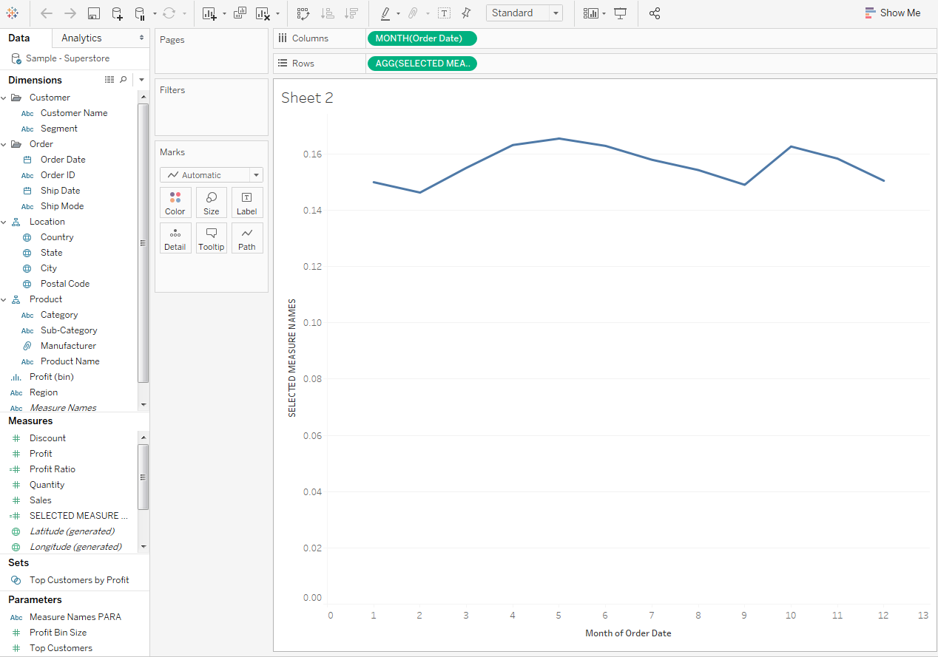

After this create a dashboard for this two sheets put it on a tile.

Create one parameter named Measure Names para in sheet one

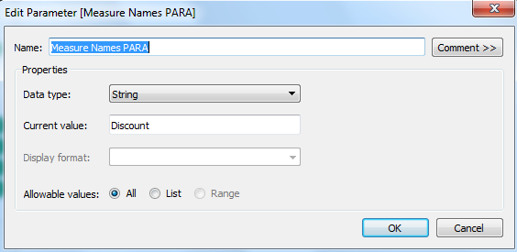

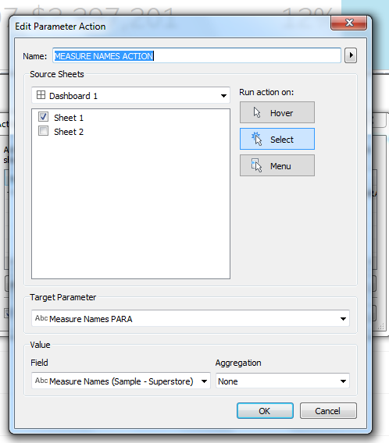

After giving the parameter actions in the dashboard named as measure names action navigating to sheet1 🡪target parameter filter to measure names parameter and field in measure names. Keep aggregate none.

After giving the action go to sheet2 and create the calculation field on Measure Names para to pass the action in sheet2 ,and drag it on the measure names named as selected measure names (calculation).

IF CONTAINS([Measure Names PARA],'Sales')THEN SUM([Sales])

ELSEIF CONTAINS([Measure Names PARA],'Profit Ratio')THEN [Profit Ratio]

ELSEIF CONTAINS([Measure Names PARA],'Discount') THEN AVG([Discount])

ELSEIF CONTAINS([Measure Names PARA],'Profit') THEN SUM([Profit])

END

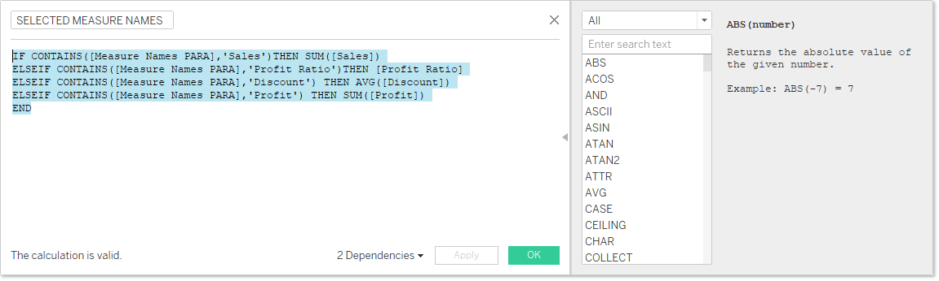

After drag the calculation part into the selected measure names after that go the dashboard to see the view and change the measure names dynamically.

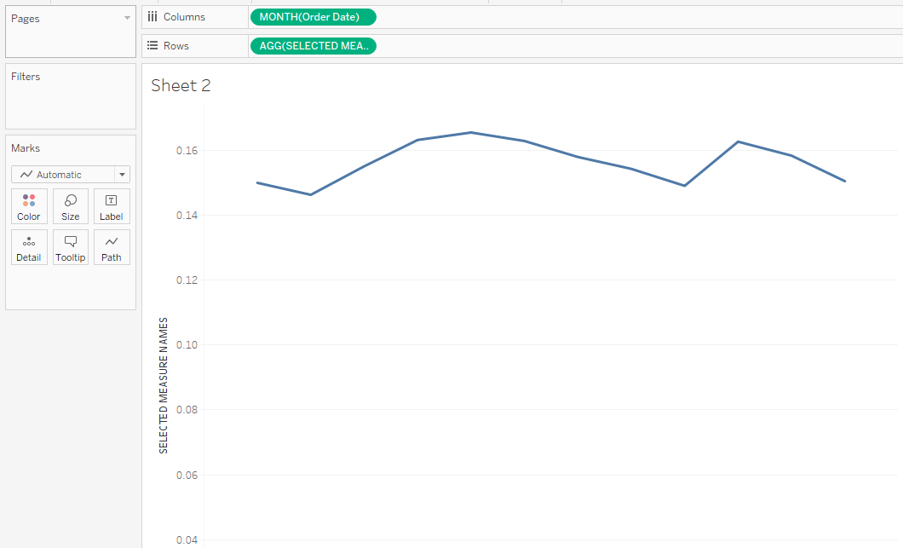

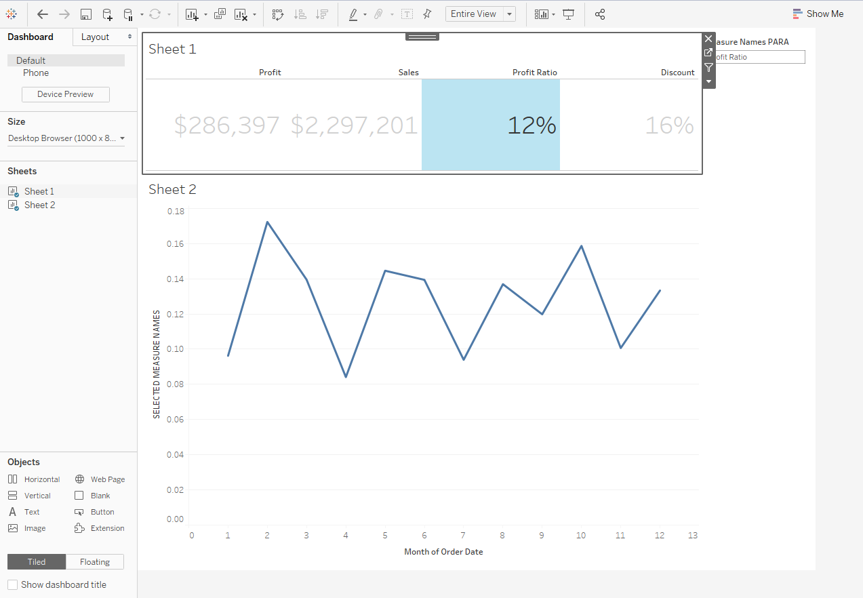

Now see the above figure just I click on the profit ratio it changes the orderdate wise view in the sheet 2 also. Here the para meter action are passing between the two sheets .now, we changed to next view

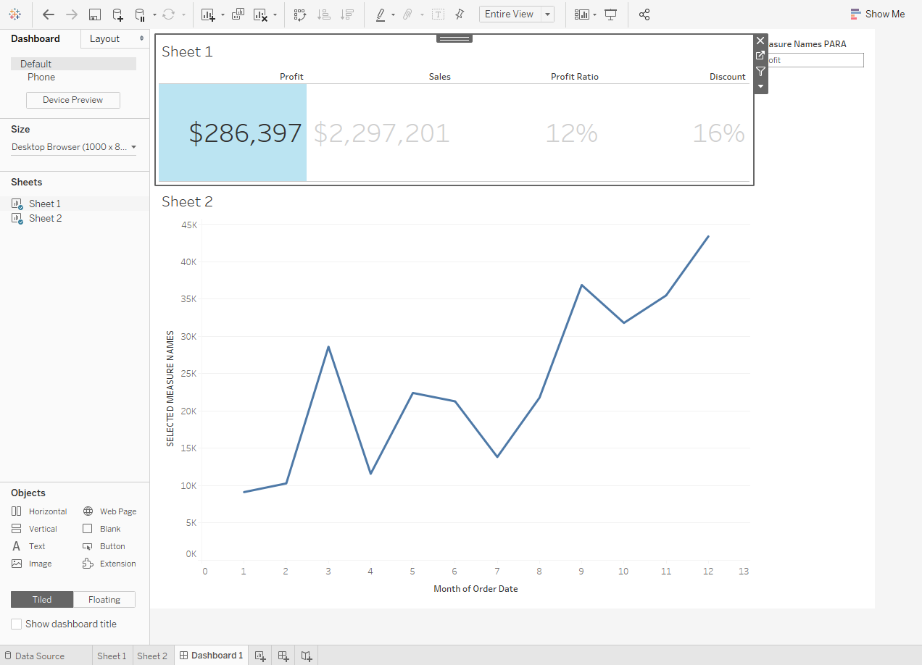

Now here your seeing the profit wise orderdate in the both sheets using the measure names ,similarly we can change the measure names dynamically in the dashboard itself for example see the below views in the dashboard.

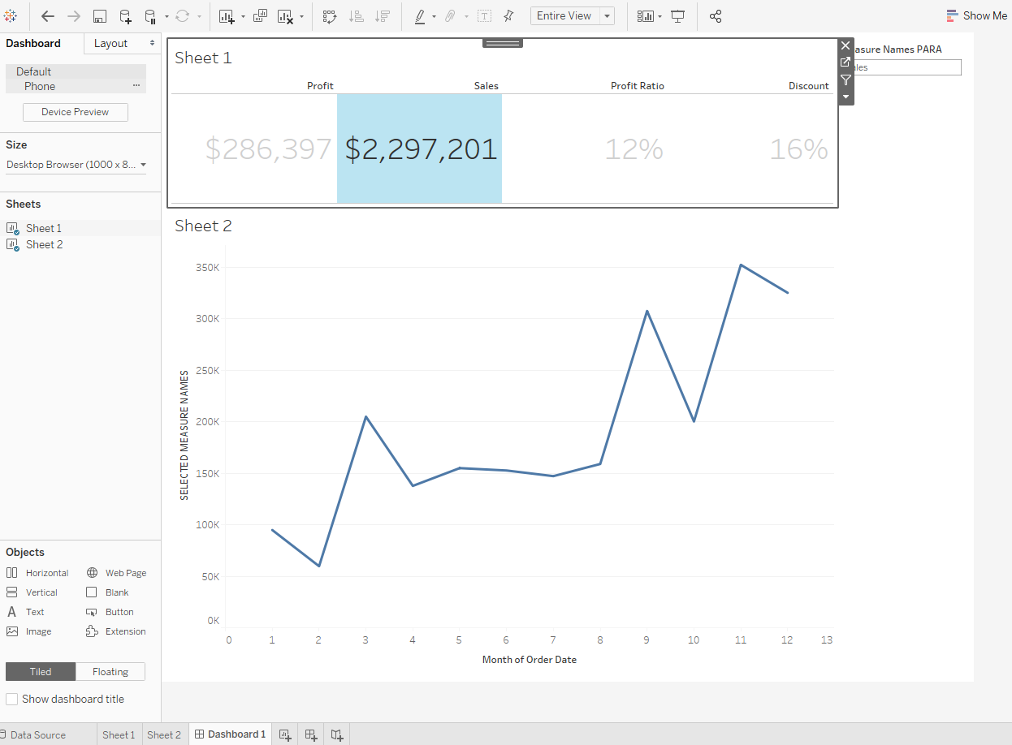

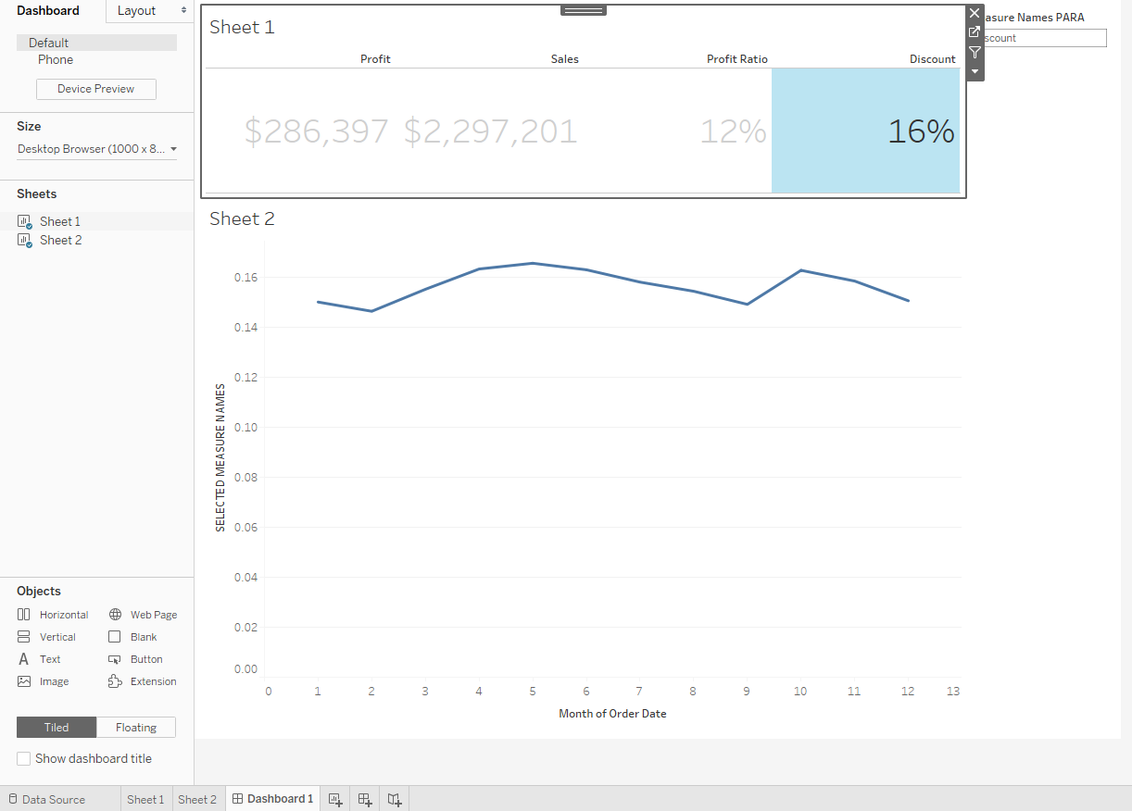

These are parameter action seen by scenario clearly in new feature from version 2019.2